Review Meeting Summary | Project Name: Development of Person Re-identification Algorithm for Basketball Ball-handlers in Complex Motion Scenarios
Meeting Time: 20:30, 7th May
Team Members: Ye Li, Chengyou Long, Siyu Lei
Main Content of the Meeting
The review meeting provided a comprehensive evaluation of the "Basketball Ball-Handler Person Re-identification" project. The team reported significant technical optimizations, including diverse data augmentation strategies, such as simulating motion blur, environmental lighting changes, and reinforced random erasing, to handle the challenges of occlusion and poor image quality. It was formally announced that the project has successfully met all preliminary competition requirements, achieving a Rank-1 accuracy of 94.3% and an mAP of 91.5%, both of which exceed the baseline targets. Furthermore, all technical documentation and primary model training for the initial milestone have been prepared and submitted on schedule. During the session, seven reviewers conducted a multi-dimensional assessment of the project. While they commended the clear technical roadmap, meticulous project management (including WBS and RBS), and the fact that the project is significantly ahead of schedule, they also raised critical inquiries. Specific questions were directed at how the team manages the high overhead of testing various augmentation combinations, the methodology behind fine-grained feature decoupling (such as distinguishing between jerseys, physique, and sneakers), and the decision-making process for selecting optimal training strategies. The reviewers also suggested deeper analysis into why actual hours were lower than planned and recommended providing more concrete visual evidence of completed work.
Comments and Advice of the reviewers
Comments:
- The project's charter is clear, its technical roadmap is well-defined, and its management structure, including both the Resource Planning Structure (RBS) and Work Breakdown Structure (WBS), is very comprehensive, ensuring a clear alignment between actual progress and anticipated outcomes.
- The overall project plan is highly transparent, with a direct one-to-one correspondence between the WBS and RBS, and the Gantt chart effectively uses color coding to reflect current progress against expectations.
- The project involves a substantial workload, with detailed design elements covering the selection and optimization of both data augmentation and training strategies, resulting in a strong final performance.
- The management of the project is exceptionally clear with detailed task decomposition, and the inclusion of economic considerations compared against competition requirements is highly effective.
- The decomposition of tasks, including the schedule and division of responsibilities, is complete, and current progress is proceeding smoothly according to plan.
- The breakdown of milestones and the comparison of progress are well-executed, making the project management more comprehensive and refined.
- The proactive review of deviations between estimated and actual time usage reflects excellent time management and process control, as evidenced by the project being significantly ahead of schedule.
Advice:
- Risk Management: It is suggested to list response plans for identified risks, such as sensitivity to detection box quality, and incorporate them into the project management framework.
- Visual Evidence: The presentation could be improved by including more specific visual demonstrations of the work that has already been completed.
- Detailed Deviation Analysis: The team should provide a more detailed analysis of why the project is ahead of schedule, specifically identifying if it resulted from framework reuse, low development time, or reduced communication costs
Questions of the reviewers and Answers
Q: During development, various data augmentation strategies and other methods are combined. Excessive experimentation can lead to significant management overhead and even negatively impact the entire model. How are these costs managed in this process?
A: Model optimization requires testing multiple strategies. We select small combinations and try them one by one. Simultaneously, we save the model at rounds 20, 40, and 60, comparing key values ​​with the corresponding baseline model values. This allows for early observation of model performance and reduces time consumption.

Q: The project charter previously provided a total budget range (from 5,000 to 15,000 RMB). Has a more detailed or refined budget range been determined during actual implementation?
A: While the initial report provided a broad range, subsequent reports will further refine the budget and precisely calculate expenditures. Early server costs were approximately 200–300 RMB; labor costs have not yet been calculated but will be clearly detailed in future document supplements.

Q: A highlight of the project is the division of fine-grained features. What specific fine-grained features have been identified, and are there mechanisms designed to decouple these for identification?
A: We divide player images into parts to decouple features such as jersey number, body shape, hair accessories, and shoe color. If a player is partially occluded (e.g., the upper body), the model focuses on the visible decoupled features, such as legs and protective gear, to perform identity matching.

Q: Regarding the training strategies, how does the model make trade-offs or selections?
A: Since team members explored different optimization paths, we held group discussions to evaluate the purpose and effectiveness of each strategy. By testing and combining various iterations, we selected the most effective combinations to meet the competition requirements.
Action Plan
The action plan for the upcoming milestone is structured around three strategic pillars to ensure the project’s continued success and technical excellence. First, the team will prioritize model and strategy optimization, focusing on refining the feature decoupling mechanisms , exploring advanced loss function constraints and parameter combinations to further push the boundaries of Rank-1 Accuracy and mAP values. Second, drawing directly from the reviewers' suggestions, the team will optimize project management practices by implementing a more rigorous experimental tracking system to minimize the management overhead of multi-strategy testing and by providing a granular breakdown of project budgets and resource expenditures in future reports. Third, the team will strictly follow the competition schedule to complete the systematic organization of project outcomes, including final code encapsulation and performance benchmarking. This will culminate in the preparation of high-quality final demonstration materials and technical reports, ensuring all deliverables are finalized and polished before the ultimate project deadline in June.
Updated RBS, WBS and working hours
RBS:
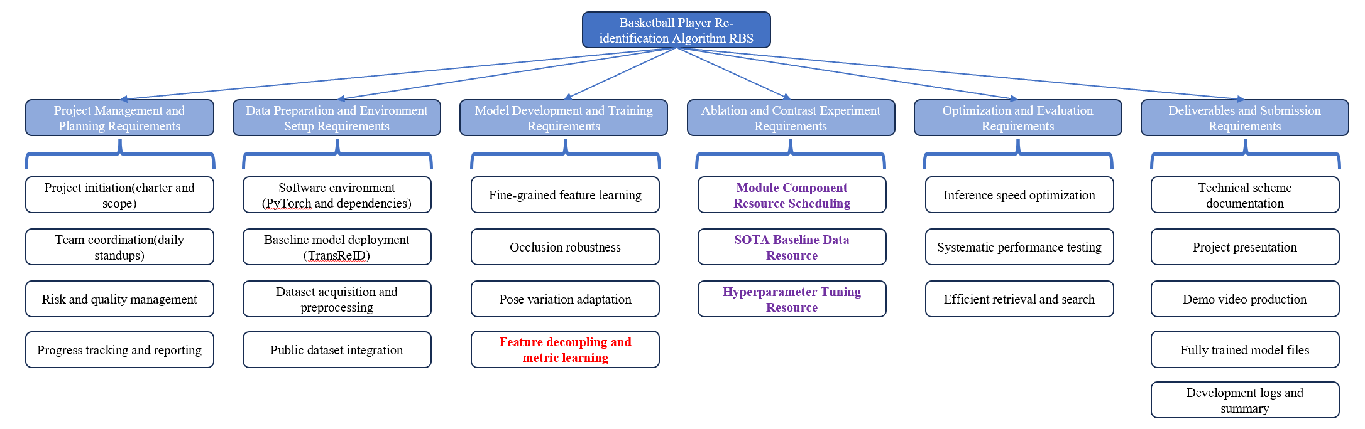
WBS:
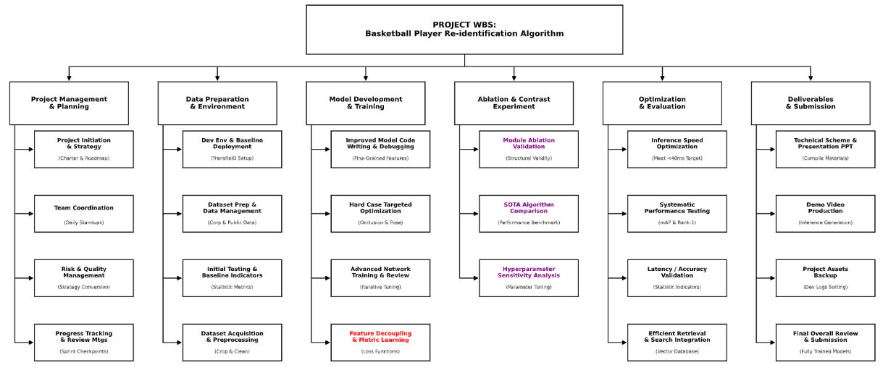
Working Hours:

In the early stage of the project, all R&D tasks advanced in an orderly manner as planned. Basic tasks including development environment configuration, dataset preprocessing and baseline model development were completed smoothly, and the required technical indicators were successfully achieved in the preliminary competition stage.
In the later stage, combined with model training results and actual business requirements, appropriate optimizations and adjustments were made to the research ideas and technical routes. We focused on promoting the optimization of feature decoupling algorithms, module ablation experiments, and comparison experiments with mainstream algorithms. Through multiple groups of controlled validations, the effectiveness and advancement of the proposed improved scheme are fully demonstrated, laying a solid foundation for subsequent model performance improvement and engineering implementation.
Signatures of Reviewers:
